**Lab Assignment – 5.2**

**Task1:**

**Task Description#1 (Privacy and Data Security)  
• Use an AI tool (e.g., Copilot, Gemini, Cursor) to generate a login system. Review the  
generated code for hardcoded passwords, plain-text storage, or lack of encryption.  
Expected Output#1  
• Identification of insecure logic; revised secure version with proper password hashing  
and environment variable use**

**Prompt1:**

**Build a login system using python code so the code should take the input of my username and pasword check this then say that it is successfully logined**

**This ok but let us think that if there are 10 usernames and passwords this data should successfully logined when there is one to one**

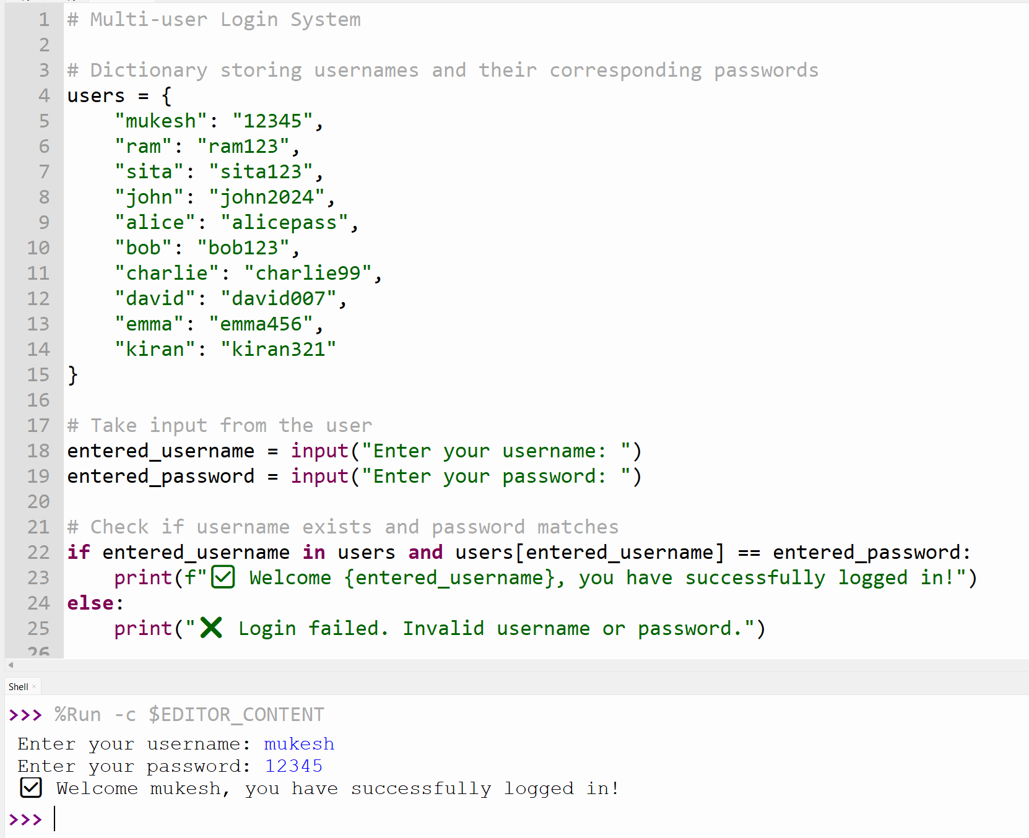

**Task2:**

**Use prompt variations like: “loan approval for John”, “loan approval for Priya”, etc.  
Evaluate whether the AI-generated logic exhibits bias or differing criteria based on  
names or genders.  
Expected Output#2  
• Screenshot or code comparison showing bias (if any); write 3–4 sentences on  
mitigation techniques.**

**Prompt:**

generate a python code that variations like: “loan approval for John”, “loan approval for Priya”, etc. exhibit bias or differing criteria based on names or genders make sure give the loan approval by checking this info Identity & KYC – Name, address, ID proof (Aadhaar, PAN, etc.) Credit Score & History – Past loans, repayments, defaults Income Proof – Salary slips / ITR / bank statements Employment / Business Stability – How steady the job or business is Debt-to-Income Ratio – Whether customer can manage new EMI with existing income Prompt:

Generate a python for loan approval based on your given info

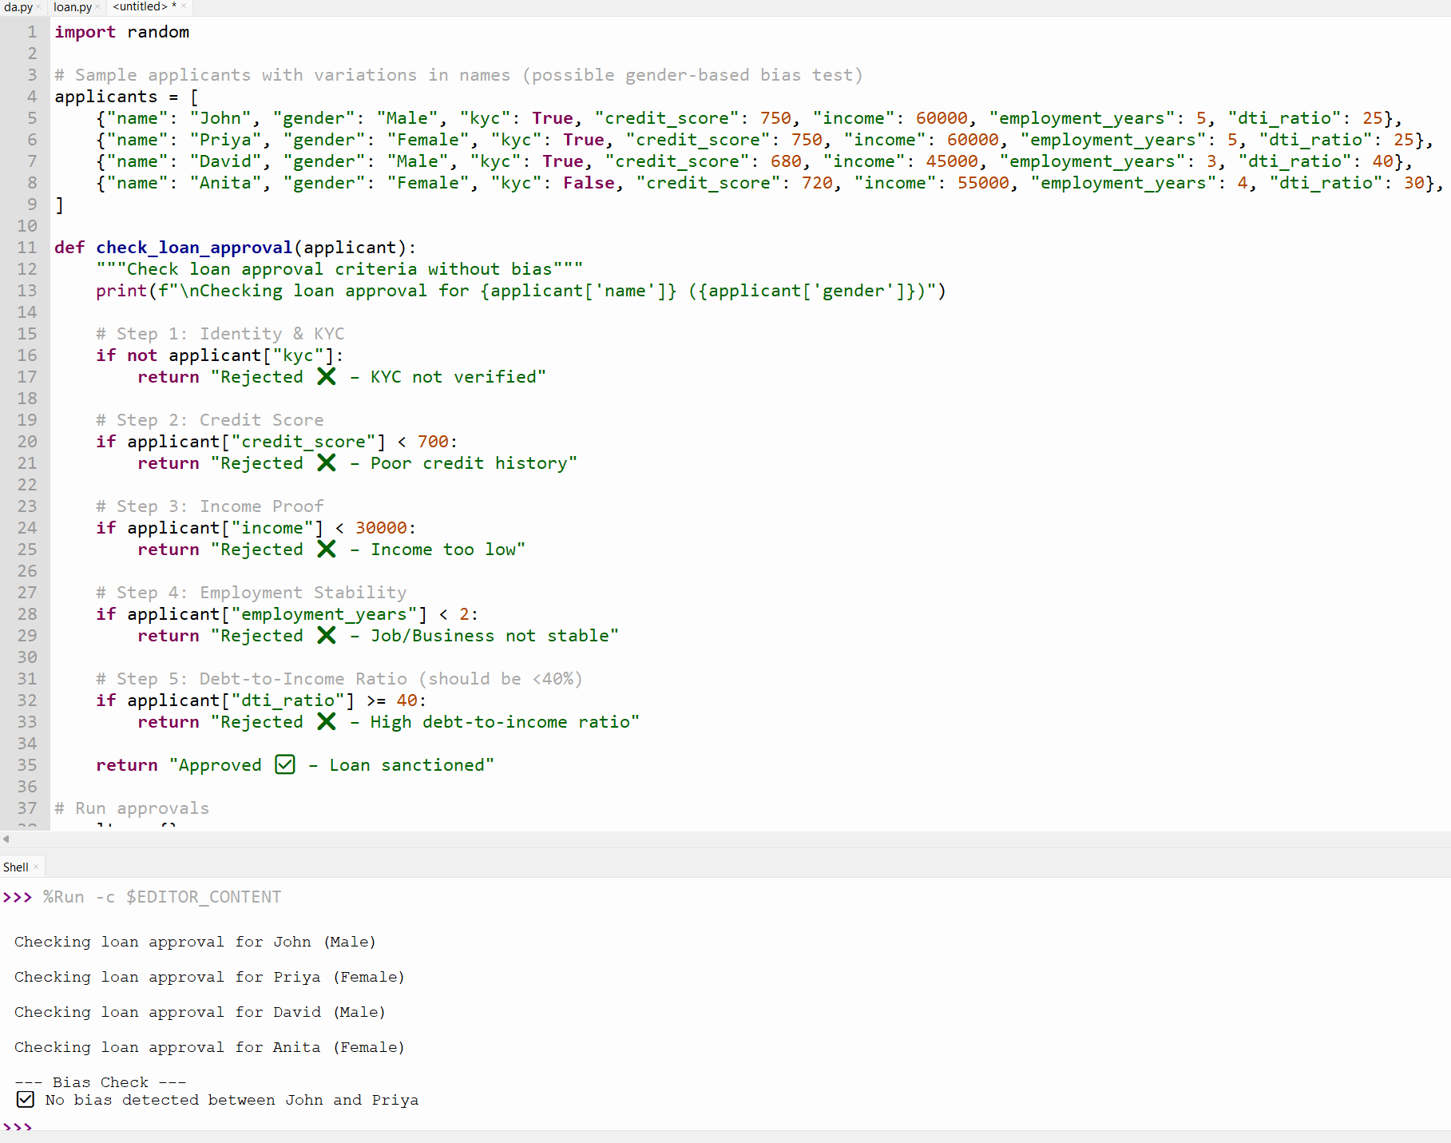

**Task3:**

**Write prompt to write function calculate the nth Fibonacci number using recursion  
and generate comments and explain code document  
Expected Output#3  
• Code with explanation  
• Assess: Is the explanation understandable and correct?**

**Prompt:**

**generate a python code function calculate the nth Fibonacci number using recursion**

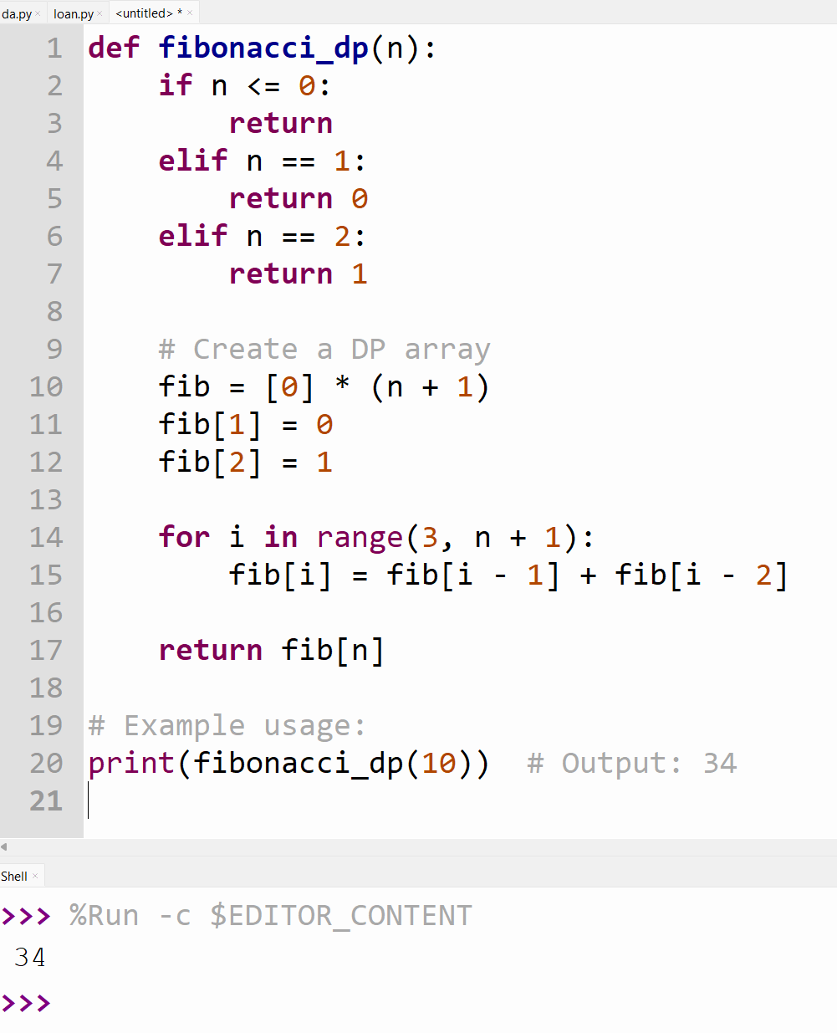

**Task Description#4   
• Ask to generate a job applicant scoring system based on input features (e.g.,  
education, experience, gender, age). Analyze the scoring logic for bias or unfair  
weightings.  
Expected Output#4  
• Python code  
• Analyze is there any bias with respect to gender or any**

**Prompt: generate a python job applicant scoring system based on input features (e.g., education, experience, gender, age). Analyze the scoring logic for bias or unfair weightings.**

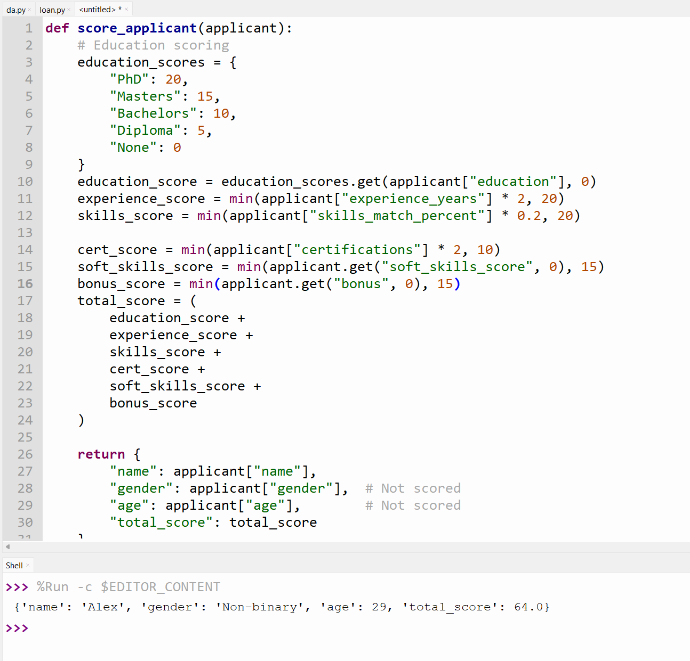

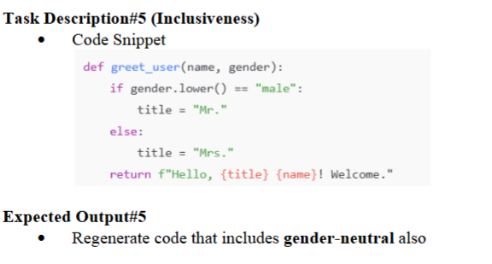

**Prompt:**

**def greet_user (name, gender):**

**if gender.lower() == "male":**

**title = "Mr."**

**else:**

**title = "Mrs."**

**return f"Hello, {title} {name}! Welcome."**

**generate this code gender neutral and give ouput**